EXPERIMENT 1
15BCE0517
M.S.SANJAY

FEATURES OF MICROPROCESSOR
8086 is a 40 pin IC.
It is a 16-bit processor.
Its operating voltage is 5 volts.
Operates in two modes: minimum mode and maximum mode, decided by the signal at MN and MX pins
Total memory addresing capacty is 1MB (external).
It has 16-bit data bus and 20-bit address bus.
It has fourteen 16-bit registers.
It has around 29000 transistors in its circuitary and it is made in HMOS technology.

2)
AIM:SIGNAL DIAGRAM OF 8086
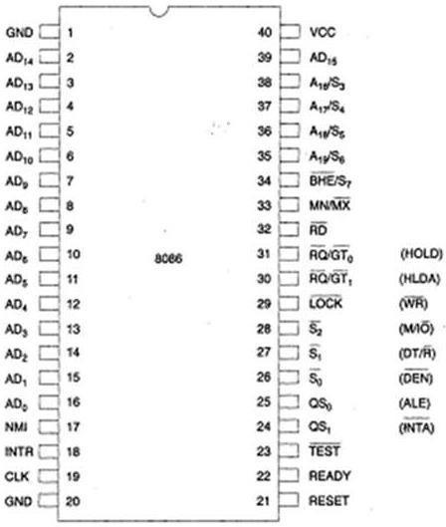

Architecture of 8086 and its working

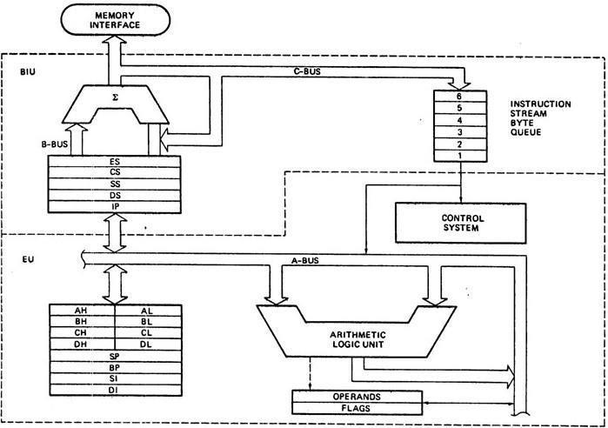

EU-Execution unit
BIU-Bus interface unit
Working principles of 8086 processor:-
The BIU outputs the contents of the instruction pointer register (IP) onto the address bus, causing the selected byte or word to be read into the BIU.
Register IP is incremented by 1 to prepare for the next instruction fetch.
Once inside the BIU, the instruction is passed to the queue.
Assuming that the queue is initially empty, the EU immediately draws this instruction from the queue and begins execution.
While the EU is executing this instruction, the BIU proceeds to fetch a new instruction. Depending on the execution time of the first instruction, the BIU may fill the queue with several new instructions before the EU is ready to draw its next instruct
The BIU is programmed to fetch a new instruction whenever the queue has room for two additional bytes. There are three conditions that will cause the EU to enter a "wait" mode or BIU to suspend fetching.
The first one occurs when the instruction requires access to a memory location. Here the BIU must suspend fetching instructions and output the address of this memory location. Then the EU will resume execution.
The second will occur when the instruction to be executed is a "jump" instruction. In this case control is to be transferred to a new non-sequential address.
The third one will occur during the execution of an instruction that is slow to execute. For example, the instruction AAM (ASCII Adjust for Multiplication) requires 83 clock cycles to complete. At fourcycles per instruction fetch, the queue will be completely filled during the execution of this singleinstruction.

addressing modes of 8086

a)Register Addressing
eg-MOV CL, DH

b) Immediate Addressing
eg-MOV DL, 08H

c) Direct Addressing
eg-MOV BL, [0400H]

d) Register Indirect Addressing
eg-MOV CX, [BX]

e) Based Addressing
eg-MOV AX, [BX + 08H]

f) Indexed Addressing
eg-MOV CX, [SI + 0A2H]

g) Based Index Addressing
eg-MOV DX, [BX + SI + 0AH]

h)String Addressing
eg-MOVS BYTE

i)Direct I/O port Addressing
eg-IN AL, [09H]

j)Indirect I/O port Addressing
Eg-OUT [DX]

k) Relative Addressing
eg- JZ 0AH

l)Implied Addressing
eg-CLC

instruction sets of 8086

The 8086 microprocessor supports 8 types of instructions −
- Data Transfer Instructions
- Arithmetic Instructions
- Bit Manipulation Instructions
- String Instructions
- Program Execution Transfer Instructions (Branch & Loop Instructions)
- Processor Control Instructions
- Iteration Control Instructions
- Interrupt Instructions
Let us now discuss these instruction sets in detail.

Data Transfer Instructions
These instructions are used to transfer the data from the source operand to the destination operand. Following are the list of instructions under this group −

Instruction to transfer a word
- MOV − Used to copy the byte or word from the provided source to the provided destination.
- PPUSH − Used to put a word at the top of the stack.
- POP − Used to get a word from the top of the stack to the provided location.
- PUSHA − Used to put all the registers into the stack.
- POPA − Used to get words from the stack to all registers.
- XCHG − Used to exchange the data from two locations.
- XLAT − Used to translate a byte in AL using a table in the memory.

Instructions for input and output port transfer
- IN − Used to read a byte or word from the provided port to the accumulator.
- OUT − Used to send out a byte or word from the accumulator to the provided port.

Instructions to transfer the address
- LEA − Used to load the address of operand into the provided register.
- LDS − Used to load DS register and other provided register from the memory
- LES − Used to load ES register and other provided register from the memory.

Instructions to transfer flag registers
- LAHF − Used to load AH with the low byte of the flag register.
- SAHF − Used to store AH register to low byte of the flag register.
- PUSHF − Used to copy the flag register at the top of the stack.
- POPF − Used to copy a word at the top of the stack to the flag register.

Arithmetic Instructions
These instructions are used to perform arithmetic operations like addition, subtraction, multiplication, division, etc.
Following is the list of instructions under this group −

Instructions to perform addition
- ADD − Used to add the provided byte to byte/word to word.
- ADC − Used to add with carry.
- INC − Used to increment the provided byte/word by 1.
- AAA − Used to adjust ASCII after addition.
- DAA − Used to adjust the decimal after the addition/subtraction operation.

Instructions to perform subtraction
- SUB − Used to subtract the byte from byte/word from word.
- SBB − Used to perform subtraction with borrow.
- DEC − Used to decrement the provided byte/word by 1.
- NPG − Used to negate each bit of the provided byte/word and add 1/2’s complement.
- CMP − Used to compare 2 provided byte/word.
- AAS − Used to adjust ASCII codes after subtraction.
- DAS − Used to adjust decimal after subtraction.

Instruction to perform multiplication
- MUL − Used to multiply unsigned byte by byte/word by word.
- IMUL − Used to multiply signed byte by byte/word by word.
- AAM − Used to adjust ASCII codes after multiplication.

Instructions to perform division
- DIV − Used to divide the unsigned word by byte or unsigned double word by word.
- IDIV − Used to divide the signed word by byte or signed double word by word.
- AAD − Used to adjust ASCII codes after division.
- CBW − Used to fill the upper byte of the word with the copies of sign bit of the lower byte.
- CWD − Used to fill the upper word of the double word with the sign bit of the lower word.

Bit Manipulation Instructions
These instructions are used to perform operations where data bits are involved, i.e. operations like logical, shift, etc.
Following is the list of instructions under this group −

Instructions to perform logical operation
- NOT − Used to invert each bit of a byte or word.
- AND − Used for adding each bit in a byte/word with the corresponding bit in another byte/word.
- OR − Used to multiply each bit in a byte/word with the corresponding bit in another byte/word.
- XOR − Used to perform Exclusive-OR operation over each bit in a byte/word with the corresponding bit in another byte/word.
- TEST − Used to add operands to update flags, without affecting operands.

Instructions to perform shift operations
- SHL/SAL − Used to shift bits of a byte/word towards left and put zero(S) in LSBs.
- SHR − Used to shift bits of a byte/word towards the right and put zero(S) in MSBs.
- SAR − Used to shift bits of a byte/word towards the right and copy the old MSB into the new MSB.

Instructions to perform rotate operations
- ROL − Used to rotate bits of byte/word towards the left, i.e. MSB to LSB and to Carry Flag [CF].
- ROR − Used to rotate bits of byte/word towards the right, i.e. LSB to MSB and to Carry Flag [CF].
- RCR − Used to rotate bits of byte/word towards the right, i.e. LSB to CF and CF to MSB.
- RCL − Used to rotate bits of byte/word towards the left, i.e. MSB to CF and CF to LSB.

String Instructions
String is a group of bytes/words and their memory is always allocated in a sequential order.
Following is the list of instructions under this group −
- REP − Used to repeat the given instruction till CX ≠ 0.
- REPE/REPZ − Used to repeat the given instruction until CX = 0 or zero flag ZF = 1.
- REPNE/REPNZ − Used to repeat the given instruction until CX = 0 or zero flag ZF = 1.
- MOVS/MOVSB/MOVSW − Used to move the byte/word from one string to another.
- COMS/COMPSB/COMPSW − Used to compare two string bytes/words.
- INS/INSB/INSW − Used as an input string/byte/word from the I/O port to the provided memory location.
- OUTS/OUTSB/OUTSW − Used as an output string/byte/word from the provided memory location to the I/O port.
- SCAS/SCASB/SCASW − Used to scan a string and compare its byte with a byte in AL or string word with a word in AX.
- LODS/LODSB/LODSW − Used to store the string byte into AL or string word into AX.

Program Execution Transfer Instructions (Branch and Loop Instructions)
These instructions are used to transfer/branch the instructions during an execution. It includes the following instructions −
Instructions to transfer the instruction during an execution without any condition −
- CALL − Used to call a procedure and save their return address to the stack.
- RET − Used to return from the procedure to the main program.
- JMP − Used to jump to the provided address to proceed to the next instruction.
Instructions to transfer the instruction during an execution with some conditions −
- JA/JNBE − Used to jump if above/not below/equal instruction satisfies.
- JAE/JNB − Used to jump if above/not below instruction satisfies.
- JBE/JNA − Used to jump if below/equal/ not above instruction satisfies.
- JC − Used to jump if carry flag CF = 1
- JE/JZ − Used to jump if equal/zero flag ZF = 1
- JG/JNLE − Used to jump if greater/not less than/equal instruction satisfies.
- JGE/JNL − Used to jump if greater than/equal/not less than instruction satisfies.
- JL/JNGE − Used to jump if less than/not greater than/equal instruction satisfies.
- JLE/JNG − Used to jump if less than/equal/if not greater than instruction satisfies.
- JNC − Used to jump if no carry flag (CF = 0)
- JNE/JNZ − Used to jump if not equal/zero flag ZF = 0
- JNO − Used to jump if no overflow flag OF = 0
- JNP/JPO − Used to jump if not parity/parity odd PF = 0
- JNS − Used to jump if not sign SF = 0
- JO − Used to jump if overflow flag OF = 1
- JP/JPE − Used to jump if parity/parity even PF = 1
- JS − Used to jump if sign flag SF = 1

Processor Control Instructions
These instructions are used to control the processor action by setting/resetting the flag values.
Following are the instructions under this group −
- STC − Used to set carry flag CF to 1
- CLC − Used to clear/reset carry flag CF to 0
- CMC − Used to put complement at the state of carry flag CF.
- STD − Used to set the direction flag DF to 1
- CLD − Used to clear/reset the direction flag DF to 0
- STI − Used to set the interrupt enable flag to 1, i.e., enable INTR input.
- CLI − Used to clear the interrupt enable flag to 0, i.e., disable INTR input.

Iteration Control Instructions
These instructions are used to execute the given instructions for number of times. Following is the list of instructions under this group −
- LOOP − Used to loop a group of instructions until the condition satisfies, i.e., CX = 0
- LOOPE/LOOPZ − Used to loop a group of instructions till it satisfies ZF = 1 & CX = 0
- LOOPNE/LOOPNZ − Used to loop a group of instructions till it satisfies ZF = 0 & CX = 0
- JCXZ − Used to jump to the provided address if CX = 0

Interrupt Instructions
These instructions are used to call the interrupt during program execution.
- INT − Used to interrupt the program during execution and calling service specified.
- INTO − Used to interrupt the program during execution if OF = 1
- IRET − Used to return from interrupt service to the main program

